|  |  |  |
| --- | --- | --- |
| **Guide Name** | | **Panel Head** |
|  | Dr. Maivizhi R | Dr. B Hariharan |
|  |  |  |
|  | **Faculty Advisor** | **Project Domain** |
|  | Dr.A.L Amutha | Research-based |
| M |  |  |
|  | **Student(s) Details: Name** | **Passport size photo(s)** |
|  | 1. Dibyajyoti Ganguly 2. Tarun Negi | C:\Users\HP\Downloads\IMG_3792.jpg |
|  |  |  |

Registration Number(s)

1. RA2011026010122

2. RA2011026010132

.

**Email ID(s)&Mobile Number(s)**

|  |  |
| --- | --- |
| 1: dg7255@srmist.edu.in, 8337090777 | 2: tn9791@srmist.edu.in, 7985857522 |
| 3: | 4: |

**Abstract Architecture Diagram**

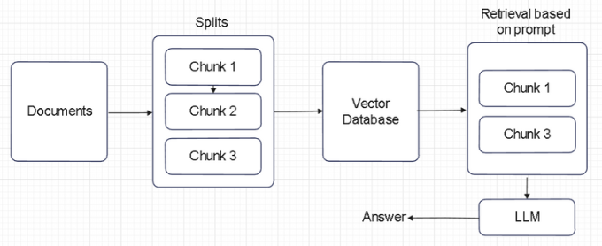

Efficiently extracting information from documents remains a critical challenge in various domains. As we witness an exponential growth in online sources, the need for efficient and intelligent tools to distill and comprehend this wealth of information becomes more pronounced. The traditional methods of research often fall short in managing the sheer volume of data available, leading to information overload and reduced productivity. Our proposed work leverages the powerful combination of Langchain and OpenAI. This innovative approach is designed to streamline research by allowing users to input documents and extracting pertinent information based on customized prompts. This enables users to provide specific prompts, tailoring the extraction process to focus on particular aspects of the news articles.

**Significance of the Project Conclusion**

The traditional methods of news research often fall short in managing the sheer volume of data available, leading to information overload and reduced productivity. This project is motivated by a desire to bridge this gap by harnessing the capabilities of Langchain and OpenAI, creating a solution that not only simplifies the research process but also enhances its precision and relevance.

The integration of Langchain and OpenAI's Language Model (LLM) presents a significant advancement in text processing and question-answering systems. By combining these cutting-edge technologies, the tool offers a comprehensive solution to address various challenges in information retrieval and analysis. Firstly, the tool streamlines the process of text extraction from PDF documents, leveraging Langchain's capabilities for efficient text processing.

**Conference/Journal Publication Details (Mandatory)**

International Conference on Intelligent Computing and Emerging Communication Technologies 22-24th August